- Go to Internet explorer and select https://portal.microsoftonline.com/
- Login with your mail Id and password and change password.
- Open thunderbird
- Click “skip and use my existing email”

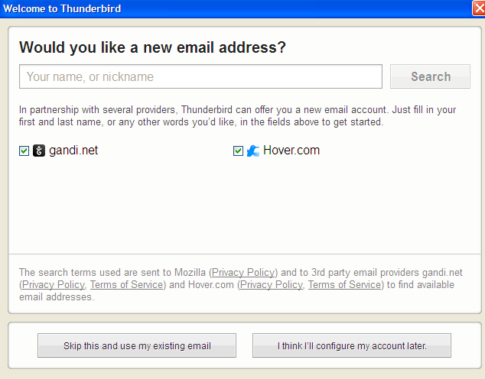
- Give your name , email address and password on below
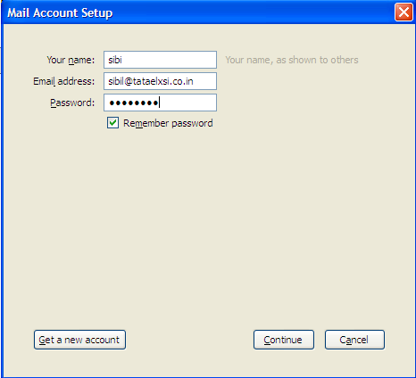
- Click continue
- Select incoming as POP3 from the drop down and configure like below
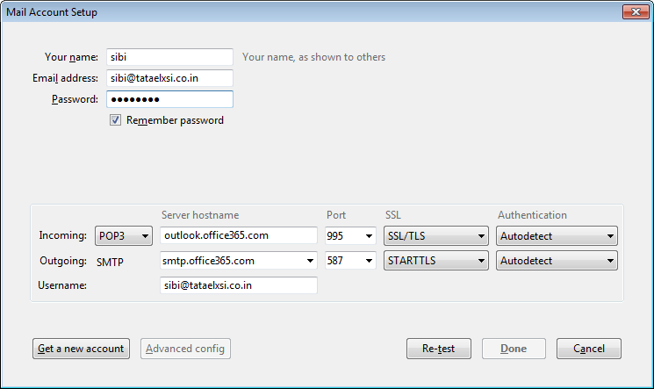
- Click advanced configuration
- Configure like below. Please note the username should be your mail address. And click OK.
- That’s All….
